**REPUBLIC OF KENYA**

**COUNTY GOVERNMENT OF ISIOLO**

OFFICE OF THE MANAGER

**ISIOLO MUNICIPALITY**

Former Barclays Bank building

Kiwanjani Estate

Next to EACC Regional Office

**ISIOLO, KENYA**

8th June, 2011

Website: www.Isiolo.municipality.go.ke

E-mail : Isiolomunicipality2018@gmail.c

P.O Box 923-60300 Isiolo

Ref: CGI/IMB/ADM/PP/025/10/23 Date: 3rd July 2023

The following is the adopted calendar for the citizen fora in accordance with section 23 of the urban areas and cities act 2011, the financial calendar 2023/2024 for the municipality citizen engagement.

|  |  |
| --- | --- |
| **QUARTER** | **DATE** |
| First (July-September) | Monday 11TH September 2023 |
| Second (October-December) | Wednesday 15th November 2023 |
| Third (January-March) | Thursday 3rd April 2024 |
| Fourth (April-June) | Thursday 3rd June 2024 |

The calendar was adopted vide minute **NO.MIN/IMB/10/7/2023-ANNUAL CALENDAR 2023-2024**

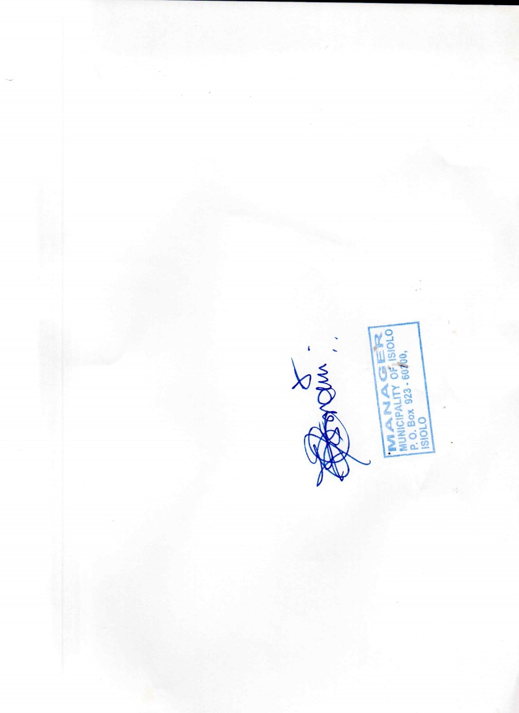

**Notice Approved By Date ……3/07/2023……**